Use of Pain Diagrams and VAS Charts Post-Procedure
Dr Geoff Harding, Sandgate Spinal Medicine Clinic, Sandgate, Qld.

Pain diagrams and pain maps have proved to be very useful in predicting sites of pain pathology in spinal conditions ¹. There is good evidence that they can predict the outcome of various interventions to obtain pain relief. Likewise, visual analogue scales (VAS) are useful in the initial assessment and then the subsequent follow-up of the progress of a pain condition. If, after an intervention, the VAS is reduced by a clinically important factor (usually at least 30% reduction) then perhaps the intervention was of use.
For those practitioners who rely on others to perform needle interventions (or any intervention for that matter), it is necessary to ensure that proper use of these pain assessment instruments is appreciated by your interventionalist. This is because in my experience, although an increasing number of radiologists are performing blocks at our behest, they often do not seem to appreciate the value of proper post-procedure follow-up with the patient. Even those who follow the ISIS Guidelines for eg medial branch block and nerve root blocks don’t always seem to understand the value of detailed assessment of the outcome. The best way to do that is by interviewing the patient at a suitable time after the procedure, by using a post-procedure pain diagram and by obtaining an appropriate VAS chart.
A search of the literature shows that most of the reference to use of pain diagrams is in the context of pre-interventional measures. Pain diagrams can be used to predict the source (or segment ) involved in the pain. However, although visual analogue scales are routinely used to rate pain after an intervention, it is not the case with post-interventional pain diagrams.
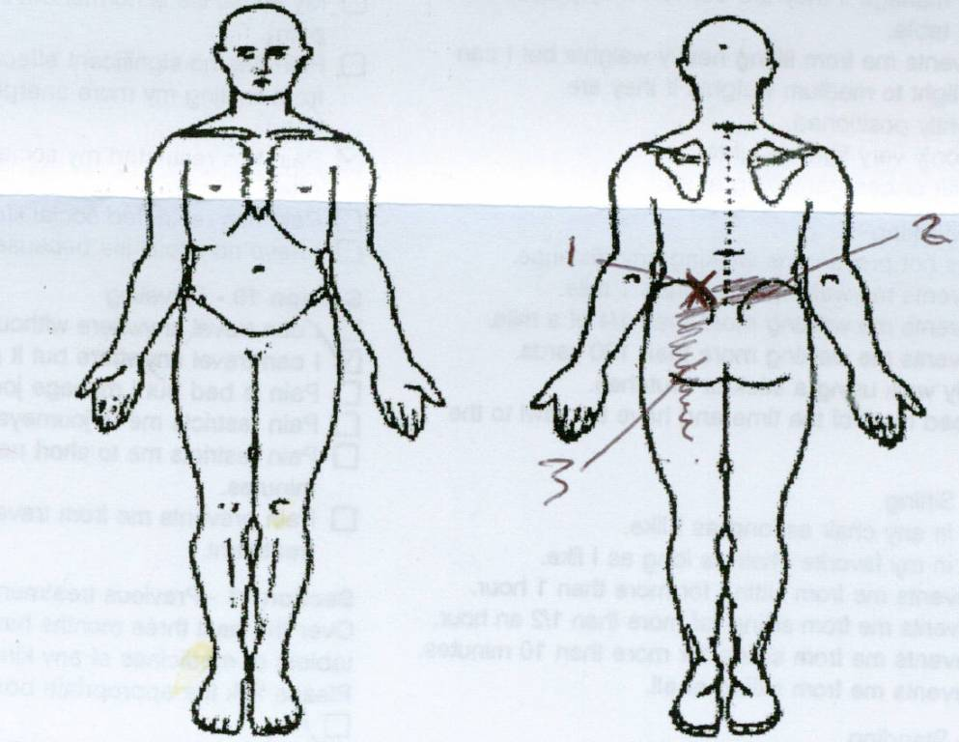Below is the pain chart of a patient who presents with a pain condition who presents to you for treatment. You might have decided (after appropriate history-taking, examination and trials of treatment) that this is an example of lumbar spine somatic referred pain. You might feel inclined to send this patient off for a medial branch block of one or two levels. Since the pain is predominately left-sided it might be better to perform left-sided blocks first and to address the right-sided component later.
Let’s say that you decide to ask for a medial branch block of the left L5S1 zygapophyseal joint. And let’s assume that you know that the radiologist uses (and will record on his report) bupivacaine 0.5% (half-life 6 – 8 hours) as the anaesthetic in this procedure. (
In my city, the patient currently is asked by the radiologist, to complete a VAS prior to the intervention, then to fill in a VAS at eight-hour intervals for the next 36 hours. No pain diagram is used and no interview takes place between the radiologist (or nurse) and the patient.
Your patient returns to you one week later to discuss the results. The patient tells you that there was no relief from the injection at all. You look at the pain chart and it indeed shows that at the first interval recorded (+8 hours) the pain level on the VAS is “7” – the same as it was prior to the procedure. What are the implications here? Likely that you will decide that the L5S1 zygapophyseal joints is not the source of the index pain.
But wait! Many patients have a “vegetable soup” of pain – some of their pain might indeed be coming from the L5S1 zygapophyseal joint, but some part of their pain might also be coming from some other (secondary) pain generator close by. I uncommonly see any patient with a pure pain pattern where all of the pain is caused by one site (or indeed one tissue). In fact, the percentage of patients with chronic low back pain having one z joint as the sole source of their pain is now said to be as low as 6%.
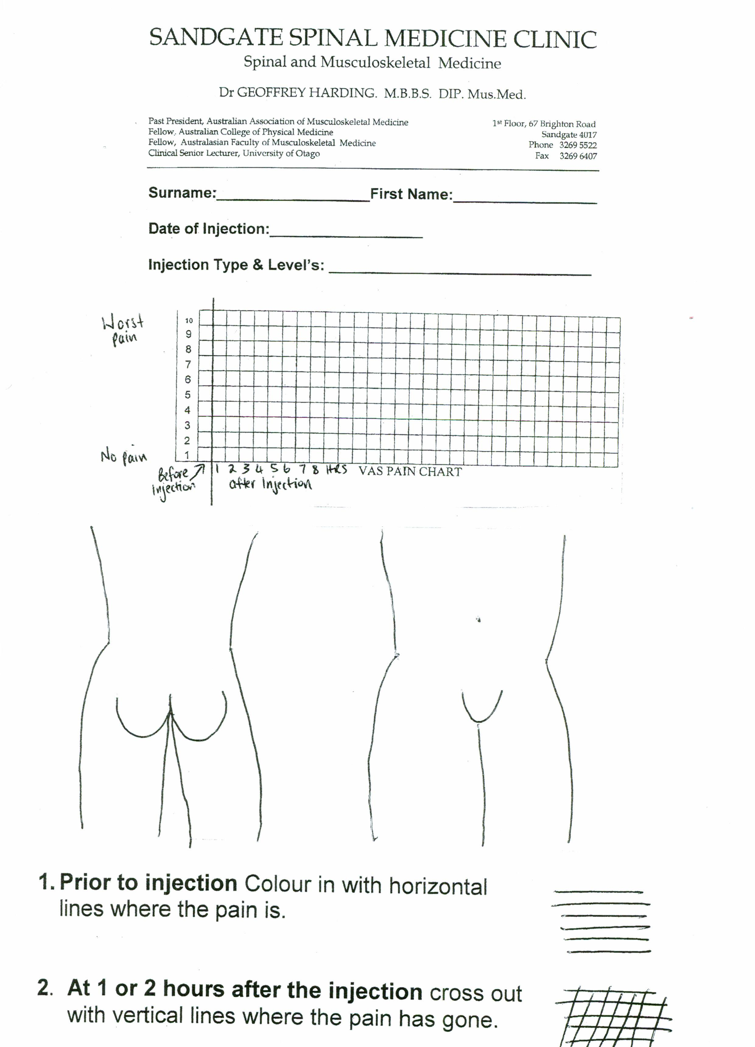What needs to be done is to first get the patient focussed prior to the intervention so as to properly assess the results. Below is the (hurriedly prepared some years ago and never altered since due to lack of time!) pain assessment tool I use for such patients. I tell them “whatever forms the radiologist gets you to fill in, I want you to complete this as well”.
You will see that they have to fill in the total area of their pain just prior to the procedure with horizontal lines and then they cross out (using vertical lines) the area where their pain either disappeared or was substantially reduced. Naturally, for a mixed pattern of pain, only part of the initial area will be crossed out. I then ask them to focus on that area (where the pain has either reduced or gone) and then fill in the VAS chart – at say 2 hours post-procedure. “Record the level of pain in this area”. “If you still have some pain elsewhere, fine, this might be coming from some other level – we can deal with that later”.
The VAS chart I use is to be filled in at hourly intervals – not 8 hourly intervals which is the norm for my city. This provides a more accurate record of the pain relief because bupivacaine only lasts a short time and it is during that time we need to monitor the pain levels.
It is also important to arrange a follow-up appointment soon after the intervention to discuss the results. The patient needs to have the whole procedure fresh in their mind – this is not possible after a one week (or more) interval. It is ideally done within two days of the procedure. It is important to tell the patient prior to the procedure that you want them to recall the details of the procedure at this appointment. “Priming” the patient in this way is more likely to yield useful information.

In my practice I usually find that there are areas of the pain which have totally disappeared with the block whilst there are other near-by areas which are totally unaffected. If not properly assessed, patients will usually “average” their overall pain and give comments like “I think the pain dropped from a 7 to a 4” when in fact the incident pain disappeared and the other pain remained at “7”.
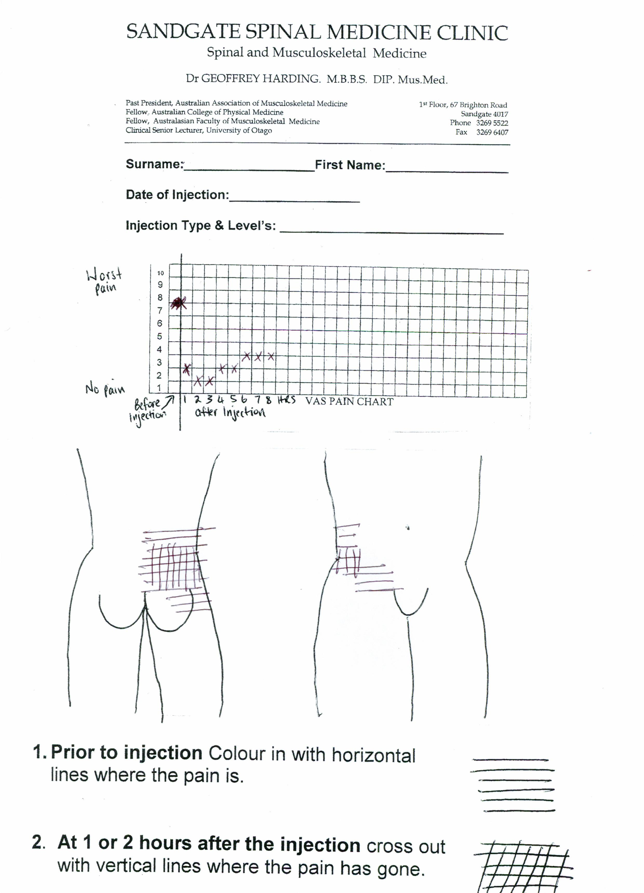In spite of my providing my patients with this type of pain assessment and telling them to take it with them, I am surprised to see that many radiologists persist in the 8-hour pain chart and nothing else.

(At another time I might be tempted to discuss the wide variation in the techniques used in performing these blocks, (in spite of the existence of the ISIS Guidelines), but that is another matter).

I would suggest that you make a copy of my pain diagram/VAS combo and give that to each patient you send off for any diagnostic block. We might be able to influence the radiologists yet!

Bogduk, N. The physiology of deep somatic pain Australasian Musculoskeletal Medicine Vol 7 No 1 May 2002

